Class Test-01:
1. What is Computer Programming?
Computer programming is the act of designing and building an executable computer program to accomplish a specific computing result.
It is a two-step process:
1 Problem Solving: Creating the logic (Algorithm) to solve a problem.
2 Coding: Translating that logic into a language the machine understands
2. Explian the Compilation Process of a source code. Difference between a compiler and an interpreter.
The three main stages are:
1 Preprocessing: Handling "starts with #" commands.
2 Compiling: Converting syntax to machine instructions (Object code).
3 Linking: Combining all parts into the final application.
Step 1-2: Preprocessing & Compiling
1. Preprocessing (The Cleaner)
Before compiling, the computer follows commands starting with #.
Example: #include<iostream> copies the contents of the header file into your program.
It cleans up the code for the compiler.
2. Compiling (The Translator)
The compiler checks for Syntax Errors (spelling mistakes in code).
If error free: It generates an Object File (.obj or .o).
This is machine code, but it is incomplete (missing library parts).
Step 3: Linking:
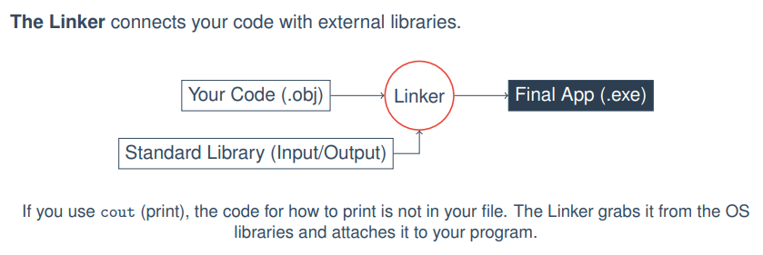
3. ExPression evaluation mathe chilo marks -7
4. Define variables in programming languages.
A Variable is a named storage location in the computer’s memory (RAM) used to hold a value.
Each variable has a name (identifier), a data type (such as integer, float, character, etc.), and a value.
Like:
The box analogy:
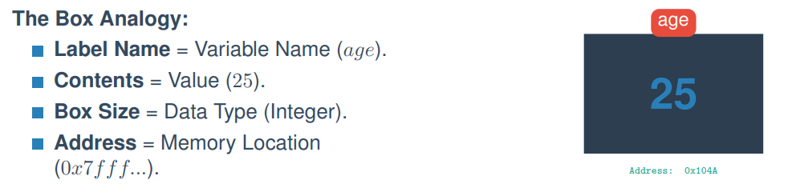
5. Different types of operator in programming languages. Demonstrate the precedence of operator in programming languages.
Different Types of Operators in Programming Languages (4 Marks)
Operators in programming languages are symbols that are used to perform operations on variables and values. Based on their functionality, operators are classified into several types:
- Arithmetic Operators
These are used to perform mathematical calculations such as addition, subtraction, multiplication, and division.
Examples: +, -, *, /, %
- Relational (Comparison) Operators
These operators compare two values and return a boolean result (true or false).
Examples: ==, !=, >, <, >=, <=
- Logical Operators
These are used to combine multiple conditions or expressions.
Examples: && (AND), || (OR), ! (NOT)
- Assignment Operators
These operators are used to assign values to variables.
Examples: =, +=, -=, *=, /=
Increment and Decrement Operators
These are used to increase or decrease the value of a variable by one.
Examples: ++, --
Precedence of operator in programming languages:
Mone rakhar shortcut techmique: P²M ARELLA
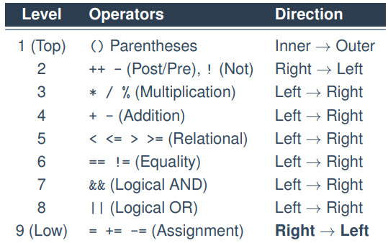
6. Given a set of instructions to compute a salesperson’s total sales and commission, implement the following instructions into valid Python programming statements to complete the program.
- Declare a variable to store the number of items sold.
- Declare a variable to store the price per item.
- Declare a variable to store the total sales and initialize it to 0.
- Compute the total sales. The total sales is equal to the number of items sold multiplied by the price per item plus a $20 bonus for meeting the sales target.
- Declare a variable to store the commission.
- Compute the commission. The commission is equal to the total sales multiplied by the commission rate (15%) plus a $10 fixed incentive.
- Type cast the total sales and commission to the nearest integer.
- Display the total sales and commission on the screen.
# Step 1: Input number of items sold
items_sold = int(input("Enter number of items sold: "))
# Step 2: Input price per item
price_per_item = float(input("Enter price per item: "))
# Step 3: Declare total sales and initialize to 0
total_sales = 0
# Step 4: Compute total sales
total_sales = items_sold * price_per_item + 20
# Step 5: Declare commission
commission = 0
# Step 6: Compute commission
commission = total_sales * 0.15 + 10
# Step 7: Convert to nearest integer
total_sales = int(total_sales)
commission = int(commission)
# Step 8: Display output
print("Total Sales =", total_sales)
print("Commission =", commission)

Example Version (Fixed Values: items = 10, price = 5)
# Step 1: Declare variable for number of items sold

items_sold = 10

# Step 2: Declare variable for price per item

price_per_item = 5

# Step 3: Declare total sales and initialize to 0

total_sales = 0

# Step 4: Compute total sales

total_sales = items_sold * price_per_item + 20

# Step 5: Declare variable for commission

commission = 0

# Step 6: Compute commission

commission = total_sales * 0.15 + 10

# Step 7: Type cast to nearest integer

total_sales = int(total_sales)

commission = int(commission)

# Step 8: Display the result

print("Total Sales =", total_sales)

print("Commission =", commission)

